OBJECT ORIENTED PROGRAMMING LAB

**Name: ATHUL VINAYAKUMAR**

**Roll No: 5 Batch: MCA B Date: 18/05/2022**

# Experiment No.: 9

**Aim**

Area of different shapes using overloaded functions.

# Procedure

class AreaShapes

{

void area(int a)

{

System.out.println("area of square is "+a*a);

}

void area(int a, int b)

{

System.out.println("area of rectangle "+a*b);

}

void area(int length, int breadth, int height)

{

System.out.println("Area of Cuboid "+(2*(length*breadth)+2*(length*height)+2*(height*breadth)));

}

}

public class CO31

{

public static void main(String[] args)

{

int a,b,c;

Scanner s= new Scanner(System.in);

AreaShapes ob=new AreaShapes();

System.out.println("enter the side of square");

a= s.nextInt();

ob.area(a);

System.out.println("enter the length and breadth");

a=s.nextInt();

b=s.nextInt();

ob.area(a,b);

System.out.println("enter the length, breadth and height of a cuboid");

a=s.nextInt();

b=s.nextInt();

c=s.nextInt();

ob.area(a,b,c);

}

}

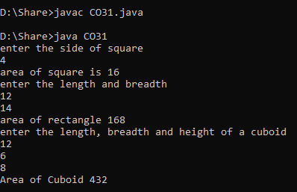**OUTPUT**